Poster  
TITLE  
Psychometric Network Analysis and Ideal Points Assessment: Developing Ideal Employees  
  
SHORTENED TITLE  
Developing Ideal Employees  
  
ABSTRACT  
We explore the possibility of applying network analysis to ideal point personality assessment data. We consider how ideal point personality data might be used as part of coaching interventions in order to develop employee into ideal organizational citizens.

PRESS PARAGRAPH  
In recent years interest in ideal point measurement and psychometric network analysis has increased in the field of personality assessment among both researchers and practitioners. However, no research we are aware of has considered using both of these techniques jointly. Here, we focus on the application of psychometric network analysis to ideal point personality measurement model data. We explore how ideal point personality assessment data–which identifies nuanced differences in personality trait standing–might reveal levers for causing personality change. We then consider how such knowledge might be used to coach employees into ideal organizational citizens. We close with a call for field / experimental research into this area.

WORD COUNT  
2889

**Introduction**

The last decade has seen an increased interest in the use of ideal point measurement techniques, particularly for personality assessment (see Drasgow, Chernyshenko, & Stark, 2010). In ideal point measurement, individuals are assumed to endorse items that reflect their precise standing on a trait, and thus promotes the use of item content that spans the trait continuum (high, moderate, and low). For example, an individual who is more moderate in achievement motivation would be more likely to endorse the item “I prefer to be above average at things but don’t have to be the very best” than someone with more moderate trait standing. This is because the person with extreme achievement motivation would disagree “from above” the item (Roberts, Laughlin, & Wedell, 1999). Research increasingly supports the theoretical (LaPalme, Tay, & Wang, 2017) and empirical (Stark, Chernyshenko, Drasgow, & Williams, 2006) fit of ideal point models to personality test responses, and their ability to more accurately detect complex relationships (Carter et al., 2017).

Notably, ideal point *measures* include moderately-worded items which reflect average trait standings as well as traditional extreme-worded items such as “I always go above and beyond what is expected”). In other words, ideal point measurement *models* flexibly handle both moderate and extreme item content (Stark et al., 2006). Further, the use of ideal point *measures*– built to include moderate and extreme item content – has been shown to increase reliability of measurement across the trait continuum (Chernyshenko et al., 2007). The advantages of measures built to ideal point specification have spurred interest both within the psychometric literature, and among practitioners.

Due to its methodological nature, ideal-point research has focused largely on technical issues, such as appropriate item writing strategies, model fitting, or validity gains. Surprisingly little work has explored the advantages of ideal-point inventories for understanding personality itself, such as explaining where traits come from, how they operate, and how they produce differences in behavior. These questions lie at the heart of the discipline (Fleeson & Jayawickreme, 2015) and carry theoretical implications for understanding why personality predicts work behavior (i.e., employee selection) and how personality changes over time (i.e., employee development). Given that ideal-point inventories capture a wider array of elemental differences in emotions, thoughts, and behaviors constituting the Big Five, they may be especially suited to identifying plausible mechanisms through which personality processes (deliberation, emotional regulation) accrue to form traits (individual differences).

Drawing upon a psychometric network approach to individual differences (Cramer et al., 2012), we recast the Big Five as a dynamic system of directly interacting feelings, thoughts, and behaviors. Rather than treat ‘hidden traits’ as causal forces lying behind stable behavioral patterns, the network approach models traits as consequences of mutually reinforcing interactions between specific thoughts, feelings, and behaviors (see Figure 1 for illustration). From this perspective, discrete actions like working hard to attain long-term goals, planning one’s week, and focusing on a task to completion in a person high on Conscientiousness co-occur not because of a top-down latent disposition, but because deciding to care about a long-term goal leads one to be more disciplined in allocation of personal resources. While such acts seem bonded into trait clusters for biological reasons (i.e., heritability in personality), such behavioral covariation may also reflect common learning principles, socially enforced norms, or functional explanations (Cramer et al., 2012; Fleeson & Jayawickreme, 2015; Wood, Gardner, & Harms, 2015).

--------------

Insert Figure 1 here

--------------

More to the point, this network perspective can provide a better view of the cognitive, motivational, and functional dynamics characterizing the development of the personality system, therefore favoring empirical investigations of such mechanisms. Incorporating ideal point items may offer further insight into developing employees into *ideal employees*. This can be done by pinpointing the equivalent points on a trait continuum (i.e., nodes) that are considered ideal for a given job or role in question and then coaching employees (who deviate significantly from this range) to make small changes that would bring them closer to that point on the continuum.[1] Psychometric network analysis can identify the levers practitioners might pull in facilitating these gradual changes for a given employee. For instance, suppose a job requires a relatively high level of conscientiousness (e.g., 1–2 SDs from the mean) but not every employees falls in this range. Psychometric network analysis should provide guidance for facilitating growth in conscientious for employees who lack conscientiousness by identifying what are termed “bridges”, which are plausible causal connections linking two or more item responses. Here is a plausible example. For a given individual, the conscientiousness item ‘I tend to be disorderly but also like to keep certain things tidy’ may bridge the agreeableness item of ‘I don’t like to let others down’ to the remaining network of conscientiousness items. This suggests that tapping into an employee’s compassion for others (e.g., identifying relationships that might be improved if they were more conscientious at work) might motivate conscientious behaviors at work by causing individuals to see how their work affects others (i.e., increasing task significance; Grant, 2008). That is, when we see how our work affects others, we’re motivated to take actions that those affected might view as constructive. In short, psychometric network analysis will find those functional levers we might then pull, helping us to nudge people to change in productive ways on multiple dimensions (or traits).

The current study unifies these methodological innovations by applying network analyses to a Big Five instrument developed with ideal-point item writing strategies. We contrast four major network properties with research exploring similar properties of common Big Five inventories (Costantini & Perugini, 2018; Costantini et al., 2015; Cramer et al., 2012). The first is the topology, or *large-scale structure*, of the Big Five including global node arrangement and degree to which nodes cluster together while distances between any two nodes remain small (*small-worldness*; Costantini et al., 2015). Two, we identify the nature and content of cross-trait item pairings to identify possible *bridging* components explaining observed covariance between trait factors (e.g., why do agreeable people tend to be conscientious). Three, we compare the most “central” and “peripheral” nodes with the nature of the central facets identified in past publications. Nodes which are central play a more prominent role in connecting elements of the personality system and, consequently, may be ideal targets for intervention if desiring to shift one’s personality. Finally, given the general importance of emotional stability and conscientiousness for job performance across occupations, we examine the *shortest* pathways that may explain the route through which changes in emotional stability (conscientiousness) may facilitate changes in conscientiousness (emotional stability). In all cases, we highlight areas where ideal-point items play a role in facilitating information flow in the Big Five network.

**Methods and Results**

Given space limits yet novelty of network terminology, the methods and results are presented concurrently. The data for this study come from a sample (*n* = 677) of working employees from Amazon’s Mechanical Turk (MTurk) who completed a suite of ideal point personality assessments capturing the Big Five Aspects (see Table 1 for items; also Castille, 2017; DeYoung, 2015). The marginal reliabilities of these assessments were all acceptable (ρ > .82). Psychometric network analyses (see Costantini et al., 2015) involved casting items as “nodes” in a network connected by “edges,” the strength of which corresponds to the strength of the GLASSO regularized partial correlations between items. The initial network is presented in Figure 2.

--------------

Insert Table 1 here

--------------

--------------

Insert Figure 2 here

--------------

Personality networks present items as nodes connected by edges representing statistical relationships. We implemented a Gaussian Graphical Model (GGM) on a polychoric correlation matrix using a graphical least absolute shrinkage and selection (glasso) with the extended EBIC criterium in *qgraph* 1.4.3 (Epskamp et al., 2018). There are two things to note. First, the glasso avoids spurious associations by using *regularization* to assign penalties so all edges are shrunk with small edges being set to zero. This results in a *sparse* (i.e., conservative) network that safeguards against overfitting by modeling covariance among components with as few connections as possible. Second, because the network uses partial correlations, all edges imply a relationship exists after controlling for all other nodes. Because the model is uniquely specified, it facilitates clear and unambiguous interpretation of edge-weight parameters as the strength of *unique* associations providing a putative causal skeleton. Given the larger number of items, the EBIC hyperparameter was set to a conservative .8 to err on the side of caution and we hide all partial correlations less than .05 for visual clarity. This network has 1,339 nonzero edges out of 11,175 possible edges (12%).

Several insights can be inferred about the architecture and generating processes of the Big Five. One, similar to (Cramer et al., 2012), there is clustering for four of the Big Five with Openness showing less cohesion. Two, it is possible to identify “pockets” of high interactivity (i.e., facets or unique item effects) by highlighting nodes with numerous, densely connected edges as well as their pathways to the larger network. For instance, there is a leadership pocket in the bottom of the extraversion network consisting of items about taking charge (Ex33), following others (Ex31), or enjoyment of project leadership (Ex34). Notice this cluster – while embedded in extraversion – is also distinct because it is only connected to the larger network by a few nodes, such as the belief one is able to persuade (Ex35) and make friends (Ex15) coupled with efforts to engage others (Ex5) and being averse to mediocre work (Co16). Its distinction and peripheral placement may suggest assertive aspects of Extraversion arise from social skills, effort to meet others, and a desire to improve the status quo (i.e., not be mediocre). Three, items along the Big Five borders may illuminate developmental pathways or feedback loops through which change spreads between traits. Take the conscientiousness and openness boundaries. The nodes in the lower left suggest the enjoyment of solving complex problems (O2, O3, O8) is positively linked to a high drive for achievement (Co17, Co18, Co19) whereas nodes in the center left show tolerance for variety (O9, O10, O11) as *negatively* linked to preference for order (Co8, Co7, Co6, Co9). Such countervailing effects suggest reinforcing gains in two Openness components may be associated with diverging effects in a person’s Conscientiousness network (e.g., more industrious but lower order). Interestingly, there are multiple boundary spanning items with ideal-point properties (e.g., O9, Es16, Es27, Ex17, Ex18, Co2, Co8, Co11, Co12, Ag7, Ag14, Ag21) suggesting they help elaborate unique ways trait networks collide.

The *small world* index was 2.35, which is higher than the values of 1.01 reported on the HEXACO facets (Costantini et al., 2015) but slightly lower than the 3 threshold recommended for describing a network as a small-world (Watts & Strogatz, 2015). When a network shows small-worldness, changes in any random part of the network could quickly spread across the whole system by allowing different clusters (e.g., traits) to directly influence one another (Watts & Strogatz, 2015). Results suggest the current inventory is more clearly organized than dominance-based questionnaires into separate subsystems (e.g., the Big Five with exception of Openness) which themselves influence one another by means of bridging connections. To illustrate the bridging components linking the Big Five, the initial network was arranged by the Big Five clusters with only partial correlations > .10 displayed (see Figure 3). Eighteen cross-trait item pairings remained (presented in Table 2) which might explain the often-substantial inter-correlations observed between personality factors. Whereas the reason for some linkages is not apparent (Ag23/Co3), others are commonly alluded to in the literature such as the demand for both positive affect and difficult goals in being ambitious and driven at work (e.g., Co15/Ex22). This small-world structure may be masked in personality forms developed to conform to simple structure (Costantini & Perugini, 2018) suggesting an ideal point inventory may offer a more realistic depiction of the personality system.

--------------

Insert Table 2 here

--------------

--------------

Insert Figure 3 here

--------------

**Centrality Estimation**

A typical way of assessing node importance is to compute centrality indices of the network structure (Costantini et al., 2015; Newman, 2010; Opsahl, Agneessens & Skvoretz, 2010). Three such measures are (1) *node strength*, quantifying how well a node is directly connected to other nodes by summing all of its absolute edges, (2) *closeness*, quantifying how well a node is indirectly connected to other nodes by taking the inverse of all shortest path lengths between the node and all other nodes, and (3) *betweenness*, quantifying how important a node is in the average path between two other nodes. While such indices often agree, it is possible for a node to be high on one index but low on another.[2]

The centrality plots appear in Figure 4. Several Agreeableness and Conscientiousness items were highly influential across indices, especially those dealing with manipulation (Ag25, Ag26), deliberation in action and decision making (Co1, Co5, Co20), or holding ‘moderate’ amounts of motivation (Co31, Co25). The most central conscientiousness items reflect both the “inhibitive” pole of the trait, recognized in facets broadly referring to control over one’s impulses as seen in facets such as “orderly” (Jackson et al., 2010) or “self-control” (Roberts, Chernyshenko, Stark, & Goldberg, 2005), and ‘modest’ levels of the “proactive” pole, reflected in ideal-point versions of facets labeled “achievement striving” (Costa, McCrae, & Dye, 1991) or “industriousness” (Roberts et al, 2005). Similar to past network analyses (Costantini et al., 2015), changes in inhibitory tendencies are more likely to influence the wider personality network (most likely through fringe elements of conscientiousness) whereas changes in other portions of the personality network would similarly impact tendencies towards restraint. More interesting, the proactive ideal-point conscientiousness items (Co31, Co25) had higher centrality indices due to their role in linking the larger conscientiousness network to agreeableness and extraversion.

Items from additional traits also had relatively high betweenness-centrality, meaning they occupy strategic positions connecting several groups of nodes that would be connected by longer paths without these particular items. These include Ex9 (I always look at the bright side of life), Ex16 (I am always friendly to people), Es18 (I always feel great about the person that I am), Es11 (I have a good amount of control on my cravings), and, to a lesser extent, O7 (I enjoy having abstract or philosophical conversations). By examining Figure 2 you can visualize in what respect these nodes serve as important mediators in connecting items. For instance, E9’s focus on optimism helps bridge multiple components of extraversion with fear and self-evaluative components of emotional stability (Es28, Es27, Es18).

--------------

Insert Figure 4 here

--------------

**Shortest Pathway between Emotional Stability and Conscientiousness**

Finally, a network illustrating the shortest paths between all conscientiousness and emotional stability items was computed (see Figure 5). In comparison to the first network, these networks clarify possible pathways and mediating items between these two factors. The shortest path between 2 nodes represents the minimum number of steps needed to go from one node to another, and is computed using Dijkstra’s algorithm (Dijkstra, 1959). This can be seen as a roadmap including all possible routes from destination A to destination B, but only one of these routes being quicker—this would then be the route highlighted in the shortest path network (i.e., the path targeted for coaching).

Our network illustrates the shortest path between multiple items hence highlights a diverse array of routes linking conscientiousness and emotional stability. A few general observations. First, the nodes Co21 (Tendency to misjudge situations), Es13 (Sometimes do things I later regret), and, more indirectly, Es18 (Always feel great about person I am), Es14 (Feel most alive when giving into urges), and Ex16 (I am always friendly to people) are primary hubs for multiple pathway which indirectly link both item sets. Interestingly, several of these intermediate items share a self-reflective, guilt-laden connection, such that taking time to correctly assess the consequences of one’s decision lessens the likelihood of impulsively engaging in actions, which then lead to remorse and low self-esteem. It may be possible the links between regulation of emotions and motivation can be explained by a realization that hasty actions lead to bad consequences. On a more global level, whereas most of the emotional stability items clustered together to flow into conscientiousness, the more diffuse conscientiousness network flowed down into emotional stability through a few, primarily ideal-point oriented behaviors of Co24 (Pride myself on unwavering ability to act responsibly), Co25 (Although capable of self-motivation, I prefer to have someone else provide direction), Co31 (Do just enough work to get by), and Co11 (I have lied to protect others). In other words, there appear to be many routes for emotional stability change to affect conscientiousness but only a few primary routes (primarily in being responsible or industrious) for conscientiousness to spread into emotional stability.

--------------

Insert Figure 5 here

--------------

**Conclusion**

Our results suggest there is promise in exploring the developmental applications of ideal point inventories. Many plausible bridges exist linking developmental trajectories across the personality system. Future research investigating these bridges, such as field and experimental research into this area (e.g., coaching interventions), is needed. The results indicate personality networks assessed by ideal point inventories are more clearly organized than dominance-based questionnaires (see Costantini et al., 2015), further bolstering the notion ideal point assessments offer a more realistic depiction of personality. Perhaps we will find that ideal point assessments can help practitioners develop ideal employees.

**Reference**

Borsboom, D., & Cramer, A.O.J. (2013). Network analysis: An integrative approach to the structure of psychopathology. *Annual Review of Clinical Psychology*, 9, 91–121.

Boschloo, L., van Borkulo, C. D., Borsboom, D., & Schoevers, R. A. (2016). A prospective study on how symptoms in a network predict the onset of depression. *Psychotherapy and Psychosomatics*, 85(3), 183-184.

Carter, N. T., Dalal, D. K., Boyce, A. S., O’Connell, M. S., Kung, M.-C., & Delgado, K. M.   
(2014). Uncovering curvilinear relationships between conscientiousness and job performance: How theoretically appropriate measurement makes an empirical difference. *Journal of Applied Psychology*, 99(4), 564-586.

Carter, N. T., Dalal, D. K., Guan, L., LoPilato, A. C., & Withrow, S. A. (2017). Item response   
theory scoring and detection of curvilinear relationships. *Psychological Methods*, 22, 191-203.

Castille, C. (April, 2017). *Cross-validation of an unfolding measurement model of the cybernetic big 5 theory traits*. Paper presented as part of a symposium for the annual conference of the Society for Industrial & Organizational Psychology, Inc. Orlando, FL.

Chernyshenko, O. S., Stark, S., Drasgow, F., & Roberts, B. W. (2007). Constructing personality   
scales under the assumptions of an ideal point response process: Toward increasing the flexibility of personality measures. *Psychological Assessment*, 19(1), 88.

Costa, Paul & R. McCrae, Robert & A. Dye, David. (1991). Facet Scales for Agreeableness and Conscientiousness: A Revision of the NEO Personality Inventory. *Personality and Individual Differences*. 12. 887-898. 10.1016/0191-8869(91)90177-D.

Costantini, G., Epskamp, S., Borsboom, D., Perugini, M., Mõttus, R., Waldorp, L. J., & Cramer, A. O. (2015). State of the aRt personality research: A tutorial on network analysis of personality data in R. *Journal of Research in Personality*, 54, 13-29.

Costantini, G., & Perugini, M. (2018). A Framework for Testing Causality in Personality Research. *European Journal of Personality*, *32*(3), 254-268.

Cramer, A. O., Van der Sluis, S., Noordhof, A., Wichers, M., Geschwind, N., Aggen, S. H., ... & Borsboom, D. (2012). Dimensions of normal personality as networks in search of equilibrium: You can't like parties if you don't like people. *European Journal of Personality*, *26*(4), 414-431.

DeYoung, C. G. (2015). Cybernetic big five theory. *Journal of Research in Personality*, *56*, 33-58..

Dijkstra, E. W. (1959). A note on two problems in connexion with graphs. *Numerische mathematik*, *1*(1), 269-271.

Drasgow, F., Chernyshenko, O. S., & Stark, S. (2010). 75 years after Likert: Thurstone was right!. *Industrial and Organizational Psychology*, *3*(4), 465-476.

Epskamp, S., Maris, G.K.J., Waldorp, L.J., & Borsboom, D. (2016). Network psychometrics. Retrieved 28 June 2017 from <https://arxiv.org/pdf/1609.02818.pdf>

Fleeson, W., & Gallagher, P. (2009). The Implications of Big Five Standing for the Distribution of Trait Manifestation in Behavior: Fifteen Experience-Sampling Studies and a Meta-Analysis. *Journal of Personality and Social Psychology*, 97(6), 1097-111.

Fleeson, W., & Jayawickreme, E. (2015). Whole trait theory. *Journal of Research in Personality*, *56*, 82-92.

Grant, A. M. (2008). The significance of task significance: Job performance effects, relational mechanisms, and boundary conditions. *The Journal of Applied Psychology*, *93*(1), 108–124. <https://doi.org/10.1037/0021-9010.93.1.108>

Ilies, R., Arvey, R. D., & Bouchard, T. J. (2006). Darwinism, behavioral genetics, and organizational behavior: A review and agenda for future research. *Journal of Organizational Behavior*, 27(2), 121-141.

Fleeson, W., & Jayawickreme, E. (2015). Whole trait theory. *Journal of Research in Personality*, *56*, 82-92.

Jackson, J. J., Wood, D., Bogg, T., Walton, K. E., Harms, P. D., & Roberts, B. W. (2010). What do conscientious people do? Development and validation of the Behavioral Indicators of Conscientiousness (BIC). *Journal of Research in Personality*, 44(4), 501-511.

LaPalme, M., Tay, L., & Wang, W. (2017). A within-person examination of the ideal point response process. *Psychological Assessment*. doi: 10.1037/pas0000499

Maydeu-Oliveras, A., Hernandex, A., & McDonald, R. (2006). A multidimensional ideal point item response theory model for binary data. *Multivariate Behavioral Research*, 41(4), 445-472.

Le, H., Oh, I. S., Robbins, S. B., Ilies, R. Holland, E., & Westrick, P. (2011). Too much of a good thing: Curvilinear relationships between personality traits and job performance. *Journal of Applied Psychology*, 96, 113-133.

Lundahl, B. W., Kunz, C., Brownell, C., Tollefson, D., & Burke, B. L. (2010). A meta-analysis of motivational interviewing: Twenty-five years of empirical studies. *Research on Social Work Practice*, 20(2), 137-160.

Newman, M. E. J. (2010). *Networks: an introduction*. Oxford; New York: Oxford University Press. ISBN: 9780199206650 0199206651

Opsahl, T., Agneessens, F., Skvoretz, J., 2010. Node centrality in weighted networks: Generalizing degree and shortest paths. *Social Networks* 32 (3), 245-251

Roberts, B. W., Chernyshenko, O. S., Stark, S., & Goldberg, L. R. (2005). The structure of conscientiousness: An empirical investigation based on seven major personality questionnaires. *Personnel Psychology*, 58, 103–139.

Roberts, J. S., Laughlin, J. E., & Wedell, D. H. (1999). Validity issues in the Likert and Thurstone approaches to attitude measurement. *Educational and psychological measurement*, *59*(2), 211-233.

Roberts, J. S., Donoghue, J. R., & Laughlin, J. E. (2000). A general item response theory model   
for unfolding unidimensional polytomous responses. *Applied Psychological Measurement*, 24, 3-32.

Robinaugh, D. J., Millner, A. J., & McNally, R. J. (2016). Identifying highly influential nodes in the complicated grief network. *Journal of Abnormal Psychology*, 125(6), 747-757.

Stark, S., Chernyshenko, O. S., Drasgow, F., & Williams, B. A. (2006). Examining assumptions   
about item responding in personality assessment: should ideal point methods be considered for scale development and scoring? *Journal of Applied Psychology*, 91(1), 25-39.

Tett, R. P., & Burnett, D. D. (2003). A personality trait-based interactionist model of job performance. *Journal of Applied Psychology*, 88, 500–517.

Watts, D. J., & Strogatz, S. H. (1998). Collective dynamics of ‘small-world’ networks. *nature*, *393*(6684), 440.

Weick, K. (1984). Small wins: Redefining the scale of social problems. *American Psychologist*, 39, 40-49.

Wood, D., Gardner, M. H., & Harms, P. D. (2015). How functionalist and process approaches to behavior can explain trait covariation. *Psychological Review*, 122(1), 84-111.

Zickar, M. J., & Drasgow, F. (1996). Detecting faking on a personality instrument using   
appropriateness measurement. Applied Psychological Measurement, 20(1), 71-87.  
Asendorpf, J. B. (2016). Causal unity of broader traits is an illusion. *European Journal of Personality*, 30, 304–340.

Table 1

*Items in the ideal point Big Five personality inventory.*

|  |  |
| --- | --- |
| **Labels** | **Items** |
| O1 | I find theoretical conversations extremely boring |
| O2 | I dislike focusing on difficult problems |
| O3 | I dislike thinking too hard about things |
| O4 | I prefer to focus on mentally stimulating projects but sometimes it is nice to have time to mentally relax |
| O5 | Sometimes I enjoy solving complex problems |
| O6 | I enjoy solving complex problems |
| O7 | I enjoy having abstract or philosophical conversations |
| O8 | I really enjoy trying to tackle the most complex problems imaginable |
| O9 | I prefer stability or consistency to variety and change |
| O10 | I like change but I also need stability |
| O11 | While I do somewhat prefer variety I also enjoy stability or consistency |
| O12 | I find all artwork to be similar |
| O13 | Listening to poetry or music seems to be a waste of time |
| O14 | While listening to music is nice it is pointless |
| O15 | From time to time I like to appreciate the beauty around me |
| O16 | There have been times when a song has made me emotional |
| O17 | I see some value in art and beauty |
| O18 | I like to think about real world problems |
| O19 | People have told me I am emotionally inept |
| O20 | I am unable to reciprocate when someone talks about their feelings |
| O21 | It takes me a long time to understand other people’s emotions |
| O22 | Unless someone tells me how they feel I won’t know for sure |
| O23 | I sometimes can tell how people feel |
| O24 | If an emotion is really obvious then I can probably identify it |
| O25 | For the most part I understand others emotions |
| O26 | People talk to me because I can empathize with how they feel |
| O27 | I have a deep understanding of others emotions |
| Es1 | I am rarely frustrated by anything |
| Es2 | I like to consider myself as a very easy going person |
| Es3 | I rarely get irritated by others |
| Es4 | I am somewhat balanced in my experience of anger |
| Es5 | I am somewhat balanced in my experience of frustration |
| Es6 | I get angry easily |
| Es7 | I get frustrated easily |
| Es8 | I have a very short temper |
| Es9 | I often resist my temptations |
| Es10 | People say I have great self control |
| Es11 | I have a good amount of control on my cravings |
| Es12 | I indulge reasonably when I feel inclined to do so |
| Es13 | Sometimes I do things I later regret |
| Es14 | I feel most alive when I give into my urges |
| Es15 | I rarely get stressed out about things |
| Es16 | Sometimes I get caught up in my problems and other times I try not to worry about things that have already happened |
| Es17 | I get caught up in my problems |
| Es18 | I always feel great about the person that I am |
| Es19 | I seldom feel down in the dumps |
| Es20 | On occasion I feel blue but most of the time I don’t feel blue |
| Es21 | My mood changes about half the time |
| Es22 | My mood changes all the time |
| Es23 | I rarely become embarrassed |
| Es24 | I am always extremely afraid that I will do the wrong thing |
| Es25 | I rarely panic |
| Es26 | Occasionally I panic but I usually do not |
| Es27 | Sometimes I panic easily and other times I do not |
| Es28 | My emotions usually get the best of me |
| Ex1 | I am a socially awkward person |
| Ex2 | I sometimes feel uncomfortable when surrounded by a big crowd |
| Ex3 | I prefer to socialize in small groups |
| Ex4 | I like to do most things in large groups |
| Ex5 | I constantly try to engage with different people |
| Ex6 | People often refer to me as a downer |
| Ex7 | I am somewhat of a fun person to be around |
| Ex8 | I like to focus on the positive side of things |
| Ex9 | I always look at the bright side of life |
| Ex10 | I am an incredibly joyful person to be around |
| Ex11 | I am incredibly uptight around others |
| Ex12 | I always hide my true feelings from people |
| Ex13 | I usually find it hard to make friends |
| Ex14 | I am usually quiet when I meet new people |
| Ex15 | I usually find it easy to make friends |
| Ex16 | I am always friendly to people |
| Ex17 | I don’t mind loud parties but I don’t prefer them either |
| Ex18 | I tend to seek adventure |
| Ex19 | Loud parties can definitely be fun |
| Ex20 | I couldn’t live without adventure |
| Ex21 | I always take my time even when a faster pace may be needed |
| Ex22 | I generally prefer activities that require little energy |
| Ex23 | Half of the time I prefer leisurely activities and half of the time I prefer activities to be fast paced |
| Ex24 | Compared to extremely energetic people I am somewhat less energetic |
| Ex25 | My fast paced lifestyle keeps me more busy than most |
| Ex26 | My lifestyle requires a high energy level |
| Ex27 | I always try to live life to the fullest extent that I possibly can |
| Ex28 | Compared to most people I live a very fast paced life |
| Ex29 | I hate leading groups |
| Ex30 | I have no interest in leadership |
| Ex31 | I would rather follow directions than lead |
| Ex32 | From time to time I enjoy taking charge on projects but some other times I prefer others to take the lead |
| Ex33 | I am often the person to take charge of a group |
| Ex34 | I enjoy taking the lead on new projects |
| Ex35 | I can always persuade people to follow my lead |
| Ex36 | I always end up leading the groups I participate in |
| Co1 | I find that most all of my decisions are impulsive |
| Co2 | I sometimes make decisions based on instinct rather than facts and sometimes I prefer facts |
| Co3 | On occasion it can be helpful to consider all options when making decisions |
| Co4 | I prefer to have backup plans |
| Co5 | It is best to be careful when a decision has significant consequences |
| Co6 | I have difficulties working on a clean and organized desk |
| Co7 | Organization is not a priority for me |
| Co8 | While I like order and regularity I also enjoy when things are a bit chaotic |
| Co9 | I keep my workstation somewhat clean and tidy |
| Co10 | I like to plan my days in advance |
| Co11 | I have lied to protect other people |
| Co12 | I aim to tell the truth as often as possible but I can think of numerous situations that have required me to bend the truth |
| Co13 | I try to keep all of the promises I make but sometimes I am unable to deliver on them |
| Co14 | Regardless of the situation I always tell the truth |
| Co15 | I avoid setting goals but when I do I set extremely easy goals |
| Co16 | I am fine being an average worker |
| Co17 | I have a drive to succeed in my work |
| Co18 | I aspire to do well in more areas compared to most people |
| Co19 | I work extremely hard to be the very best at everything I do |
| Co20 | I put little thought into my actions |
| Co21 | I have a tendency to misjudge situations |
| Co22 | I tend to perform in most areas at the average level of other people |
| Co23 | While I often excel in what I do I also have much to learn to be better |
| Co24 | I pride myself on my unwavering ability to act responsibly |
| Co25 | Although I am capable of motivating myself to complete tasks I prefer to have someone else prompting me |
| Co26 | More often than not I depend on myself rather than others for the motivation needed to successfully complete a task |
| Co27 | Even when tasks are difficult I find a way to complete them |
| Co28 | I always get my work in on time |
| Co31 | I do just enough work to get by |
| Co32 | I find it difficult to start my work |
| Co33 | I prefer making decisions quickly rather than after thoroughly thinking things through |
| Ag1 | Being a winner is much more important than being cooperative |
| Ag2 | Cooperating with others is equally as important as winning |
| Ag3 | When someone is in need I feel as though I have to help |
| Ag4 | Cooperating with others is more important than winning |
| Ag5 | I always put the needs of others before my own |
| Ag6 | I am extremely self centered |
| Ag7 | I sometimes help a friend because it’s the right thing to do other times is because I want something in return |
| Ag8 | I frequently think about how others are doing |
| Ag9 | I worry about how people are doing |
| Ag10 | I live to serve others |
| Ag11 | Everyone has hidden intentions |
| Ag12 | I find it easier to trust in some people than in others |
| Ag13 | Honesty is the foundation of any good relationship |
| Ag14 | I feel the urge to confide in others |
| Ag15 | If someone wrongs me it is difficult for me to forgive them |
| Ag16 | Sometimes I am easy to satisfy but other times I can seem a bit pushy |
| Ag17 | While I sometimes forgive others to avoid confrontation I also often challenge others |
| Ag18 | People who know me would likely say I am generally a forgiving person |
| Ag19 | I usually try to satisfy others needs rather than my own when I sense conflict emerging |
| Ag20 | People who know me would say I am an extremely forgiving person |
| Ag21 | I shy away from credit sometimes but other times it is nice to be recognized |
| Ag22 | Sometimes the work I do is really excellent other times it is mediocre |
| Ag23 | When I give money to a charity I am fine with being anonymous |
| Ag24 | I always share the credit I receive on teamwork |
| Ag25 | I always hide my motives to get what I want |
| Ag26 | Manipulating others can be helpful |
| Ag27 | I use flattery on occasion when dealing with others |
| Ag28 | People often tell me that I am a genuine person |

Table 2.

*Eighteen bridging pair items in the inventory*

|  |  |  |
| --- | --- | --- |
| **Item Labels** | **First Item** | **Second Item** |
| Ag28.O26 | People often tell me I’m a genuine person | People talk to me because I empathize with how they feel |
| Ag13.Co5 | Honesty is the foundation of any good relationship | It is best to be careful when a decision has significant consequence |
| Ag14.Co25 | I feel the urge to confide in others | Although I am capable of motivating myself to complete tasks I prefer to have someone else prompting |
| Ag26.Co11 | Manipulating others can be helpful | I have lied to protect other people |
| Ag23.Co3 | Fine being anonymous when giving money to charity | On occasion it can be helpful to consider all options when making decisions |
| Co5.O24 | It is best to be careful when a decision has significant consequences | If an emotion is really obvious then I can probably identify it |
| Co10.O9 | I like to plan my days in advance | I prefer stability or consistency to variety and change |
| Co18.O8 | I aspire to do well in more areas compared to most people | I really enjoy trying to tackle the most complex problems imaginable |
| Co3.O24 | On occasion it can be helpful to consider all options when making decisions | If an emotion is really obvious then I can probably identify it |
| Co15.Ex22 | I avoid setting goals but when I do I set extremely easy goals | I generally prefer activities that require little energy |
| Ex9.Es18 | I always look at the bright side of life | I always feel great about the person that I am |
| Ex16.Es2 | I am always friendly to people | I like to consider myself as a very easy going person |
| Ex22.O3 | I generally prefer activities that require little energy | I dislike thinking too hard about things |
| Ex12.O20 | I always hide my true feelings from people | I am unable to reciprocate when someone talks about their feelings |
| Co1.Es14 | I find that most all of my decisions are impulsive | I feel most alive when I give into my urges |
| Co11.Es13 | I have lied to protect other people | Sometimes I do things I later regret |
| Ag25.Ex12 | I always hide my motives to get what I want | I always hide my true feelings from people |
| Ag3.Ex16 | When someone is in need I feel as though I have to help | I am always friendly to people |

Figure 1.

*Trait model according to a latent variable (left panel) and a network perspective (right panel).*

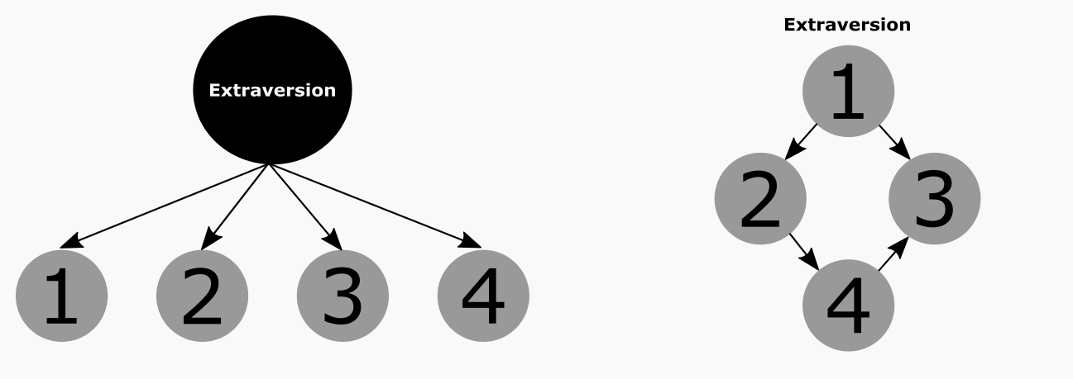

Figure 2.

*Network representation of 168 ideal-point inventory modeled after the Big Five facet structure.*

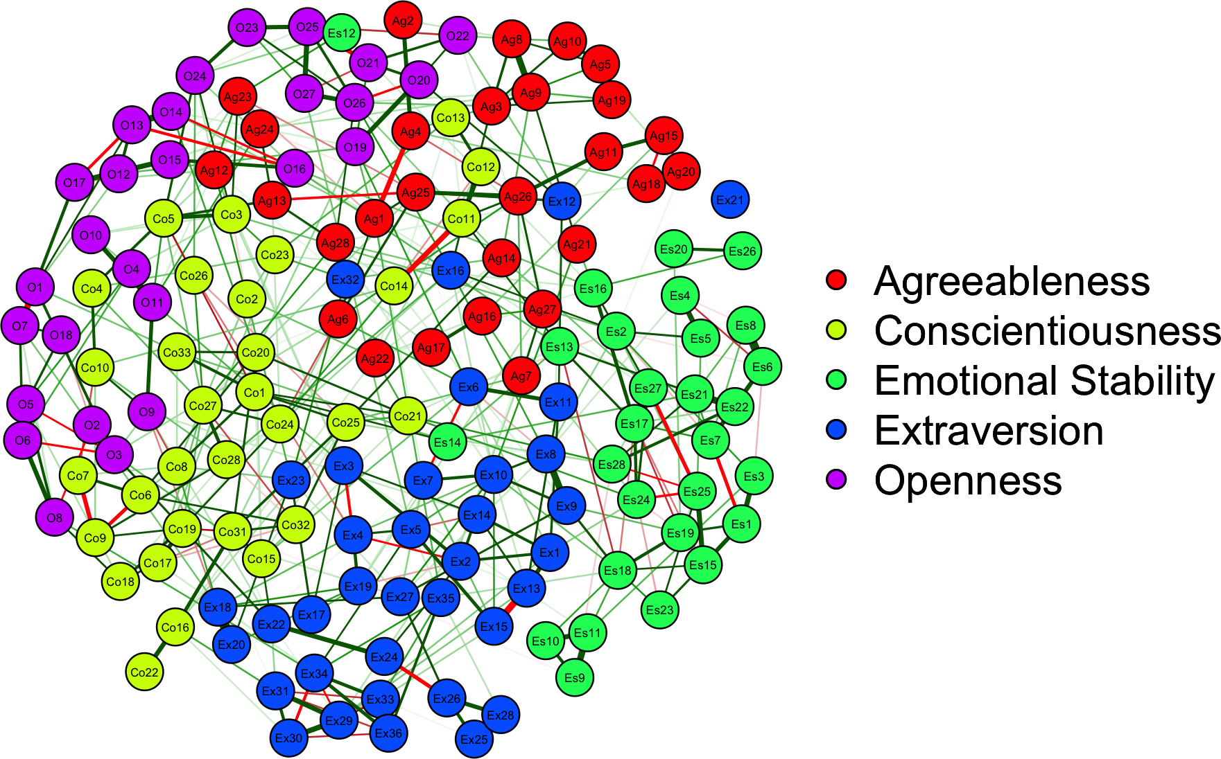

Each item is represented by a node, and the node number corresponds to the item statements in Table 1. Nodes are connected by green (red) lines if they are positively (negatively) correlated. Line thickness corresponds to correlation strength. The spring-based algorithm (Fruchterman & Reingold, 1991) used to generate the graph places strongly correlated nodes closely together and towards the middle of the graph.

Figure 3.

*Network results rearranged by Big Five groupings.*

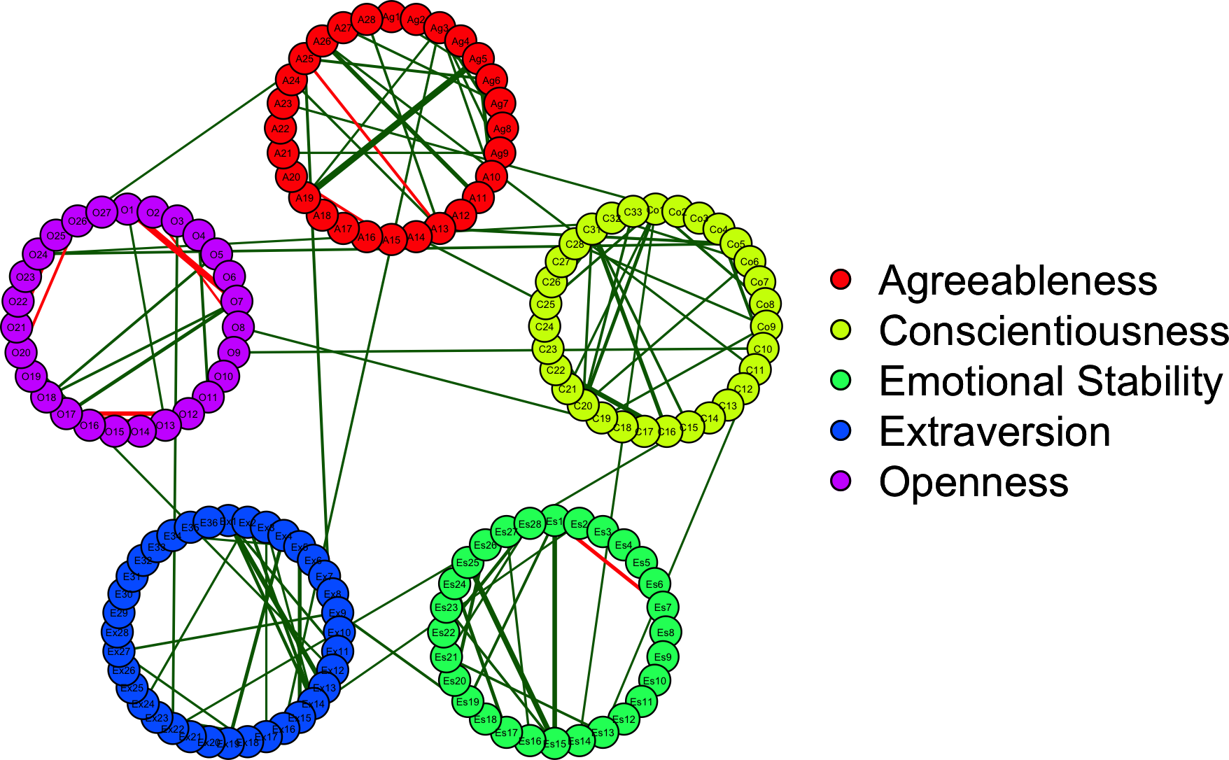

The graph has been restricted to display partial correlations .10 or greater. Visualized edges depict strong residual item associations within and between trait factors. Nodes have been rearranged and minimized, which highlights the unique clusters but also cross-trait components that remain even in the regularized matrix (akin to correlated item residuals in a factor model).

Figure 4.

*Centrality plot.*

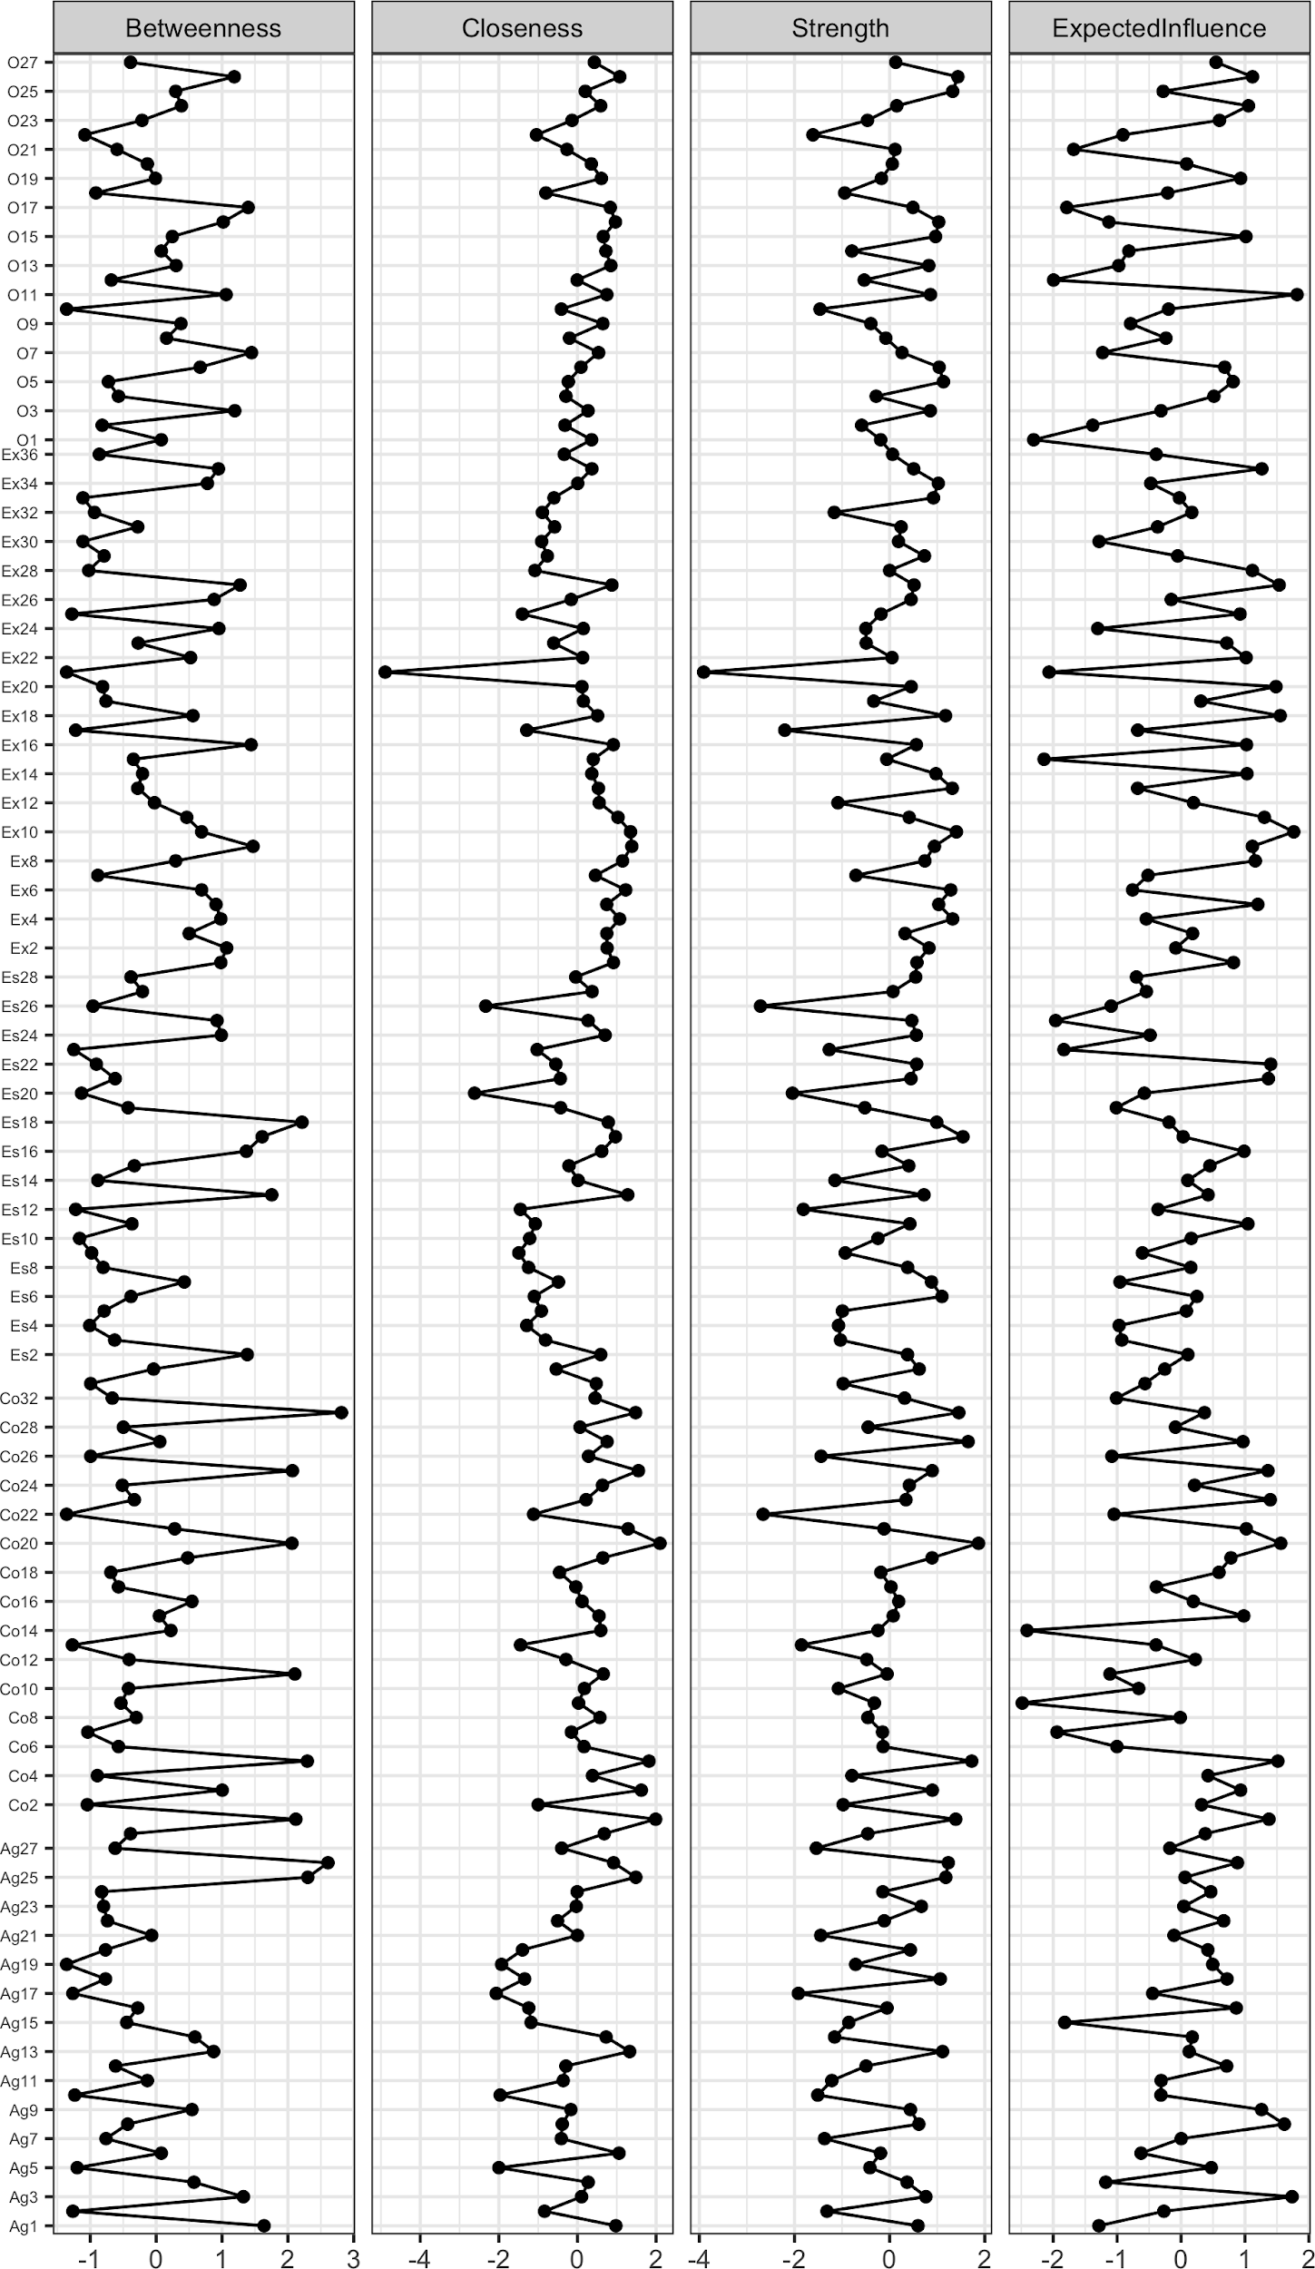

Figure 5

*Network depicting the shortest paths between conscientiousness and emotional stability items.*

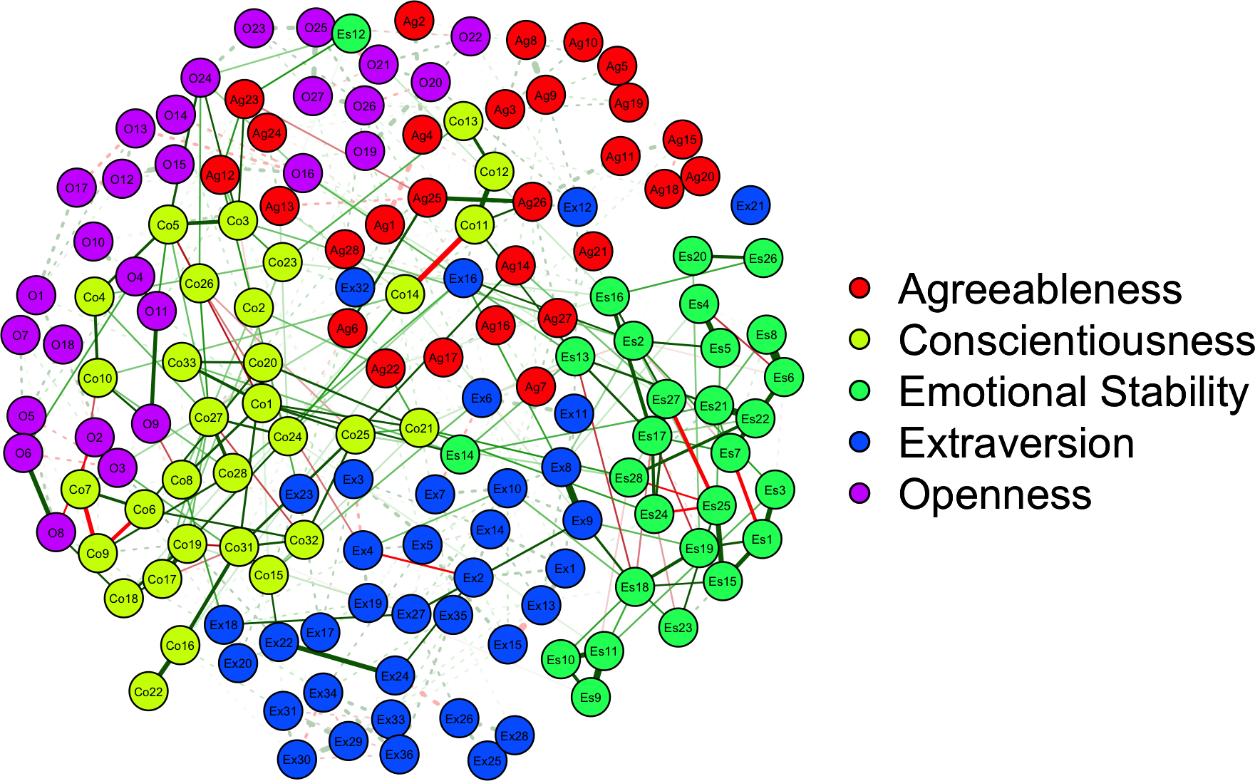

Edges belonging to the shortest-paths are full, while the other edges are dashed.

1. Please note that by ‘ideal employees’, we are referring to what the best available evidence (e.g., personality-oriented work analysis, strategic job analysis, criterion validity studies, synthetic validation studies) suggests are ideal trait profiles for a given job/role in question.
2. For instance, the Amsterdam airport would score high on *strength* as many airports fly planes in and out of Amsterdam. Comparatively, the airport in Anchorage, Alaska, while low on strength in terms of absolute number of connections, is actually higher than Amsterdam on *betweenness* because it serves as a common hub indirectly connecting many international airports to each other via oversea flights.